The time it takes for me to solve a 7x7x7 Rubik’s cube based on my time on 5x5x5

In order to do this simulation, let’s first take a glance at the general process of how to solve a high-order cube(5x5x5 and up)

1. Reduce the cube into a 3x3x3;
2. Solve it like a 3x3x3.

In this presentation I will not go into detail of how to solve a 3x3x3, since there are tons of methods and the one I use is pretty hard to explain. Therefore, in the simulation, I will just assume that the time it takes me to solve the 3x3 stage is a constant.

Instead, what the simulation is more focused on is the first part, the reduction process. The reduction process can also be broken down into these steps:

1. First four centers;
2. Last two centers;
3. First eight edges;
4. Last four edges

OK… What are centers and what are edges???

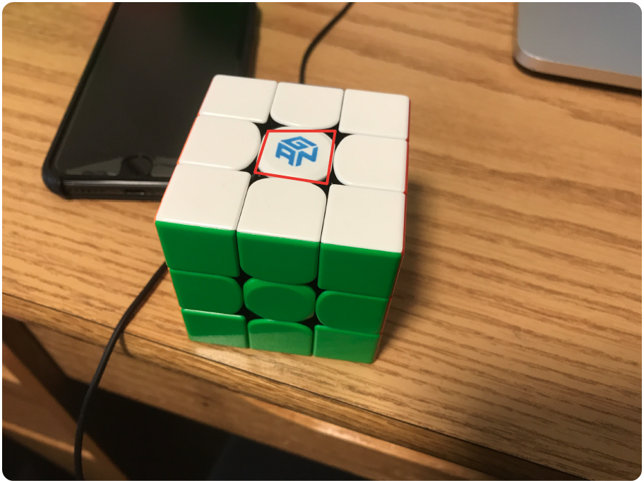Centers are pieces on a cube that only has one color on it, so for example, a center on a 3x3 would look like this:

So that is one center piece. On a 5x5, center pieces look like this:

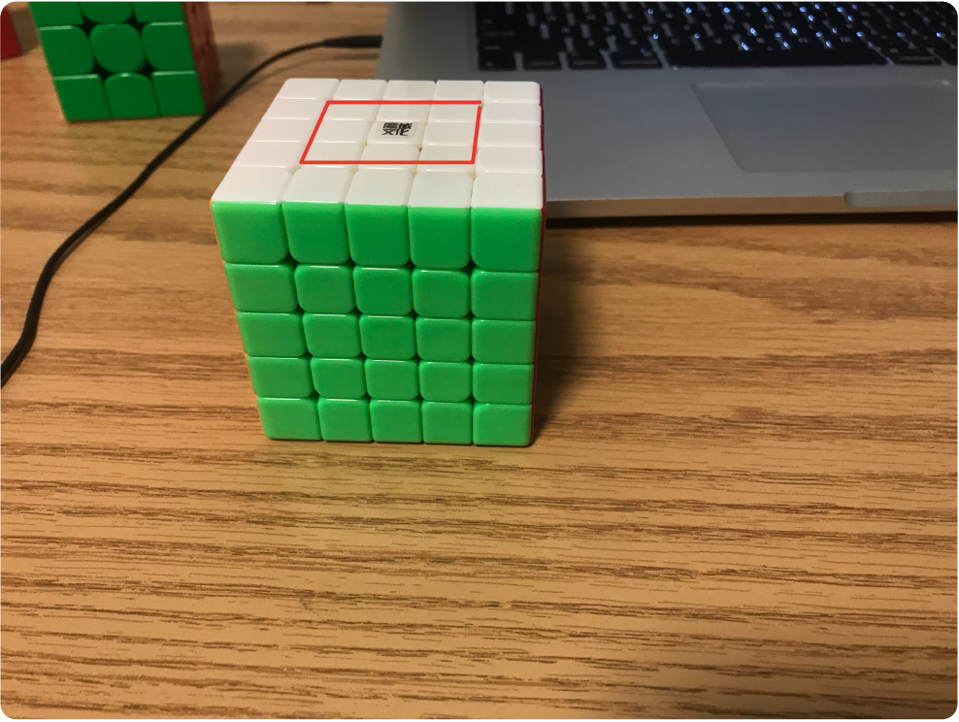

Pieces included in the red polygon are center pieces. As you can see, there are 9 center pieces for a 5x5 on each side.

What is an edge then? An edge is a piece that has two colors on it, as shown in this picture:

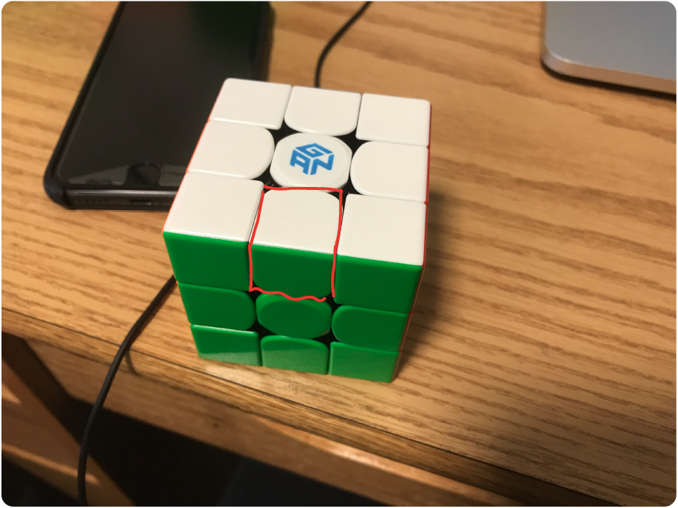

And on a 5x5, edges look like this:

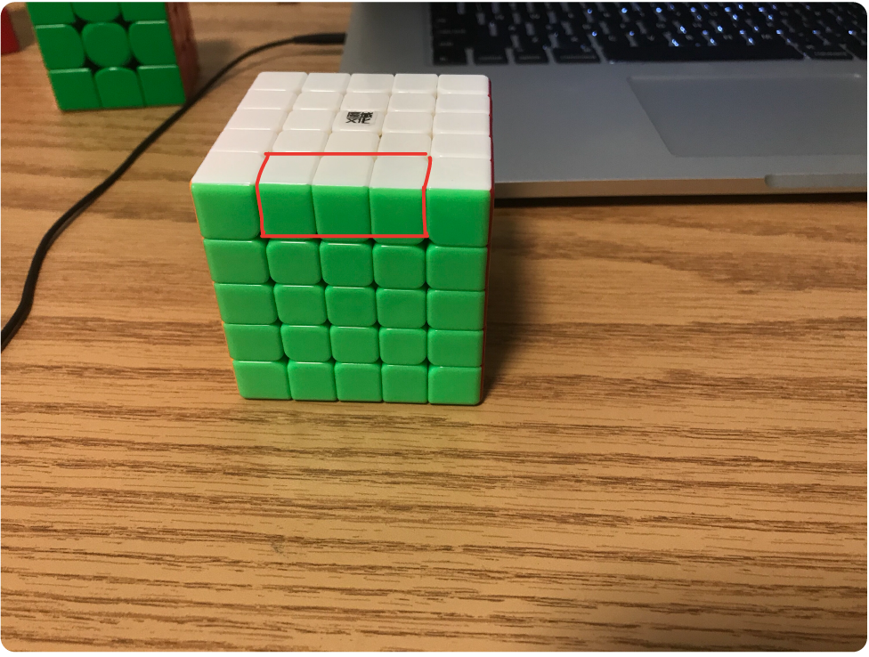

Therefore, the reduction process is basically turning a 5x5 into a 3x3.

But how can you solve a 5x5 like a 3x3?

The answer is to turn outer layers only.

If you treat all the center pieces inside the red polygon in the second image as a single center pieces on a 3x3, and all the edges in the fourth image the same as a single edge pieces in image 4, then the cube can be seen as the same.

In other words, to reduce a big cube is the same as to find centers pieces that have the same color, and put them on one side; find all edge pieces that have the same color and combine them.

So solving the first four centers is to have 4 3x3 centers on a 5x5, and last 2 centers is to solve the remaining two centers. They are separated because the way to solve them are a little bit different. Similarly, the way to pair up the first eight edges is different from the way to pair up the last four edges.

These are times it takes me do each step on a 5x5

for 5x5:

first 4 centers: 35s-60s

last 2 centers: 10s

first 8 edges: 90s-110s

last 4 edges: 20s-60s

3x3 stage:20s-35s

for each piece on the cube:

first 4 centers: lower bound: 35/32 = 1.09s/piece , upper bound: 60/32 = 1.875s/piece

the number is divided by 32 because there are 32 pieces to solve during this stage; there are 9 centers pieces on each side, but the middle center piece never move, so there are only 8 center pieces that need to be solved for each side, and there are 4 sides to solve, so the pieces that I need to solve is 8\*4 = 32

for each bar:

last 2 centers:3.33s/bar

for the last two centers, you build 1x3 bars. The time it takes me to solve a bar is approximately 3.33s. Last two centers are actually really different from the first 4 centers in a way that there are algorithms and cases are really easy to recognize, but the general idea for last 2 centers for both 5x5 and 7x7 are to build bars, so I’ll just say it takes me 3.33 seconds to solve a bar.

(PS: This is actually inaccurate because the time it takes to build a bar on 5x5 is different from that on a 7x7 because a bar on 5x5 is 1x3, while a bar on 7x7 is 1x5)

for each piece

first 8 edges: 90s/8/3=3.75s, 110s / 8/3 =4.58s

For first 8 edges on a 5x5, each of the edge consists of three small edges pieces. In total, there are 24 edge pieces that needs to be solve during this stage. On average, the fastest it takes me 90 seconds to solve the first 8 edges, so the time it takes me to solve each one would be 3.75 seconds. Same applies to the upper bound.

last 4 edges:20-60 seconds

Last 4 edges is solved in a very different way than the first 8. In this stage, you are not really solving it piece by piece, so I just estimated this stage as a whole.

(Inaccurate result for the same reason as the last 2 centers. There are 5 edge pieces for each edge on a 7x7 while there are only 3 on 5x5. The accurate estimate should be 20/3\*5=33.3, 60/3\*5=100

3x3 stage:20-35 seconds

This is just an estimate of the final 3x3 stage of the solve. Not going to go into details how to solve a 3x3, but there is not difference between 3x3 stage on a 5x5 and 3x3 stage on a 7x7.

There are 4 random variables, so it took a long time to run this… First I ran 100 trials, and the graph looks like this:

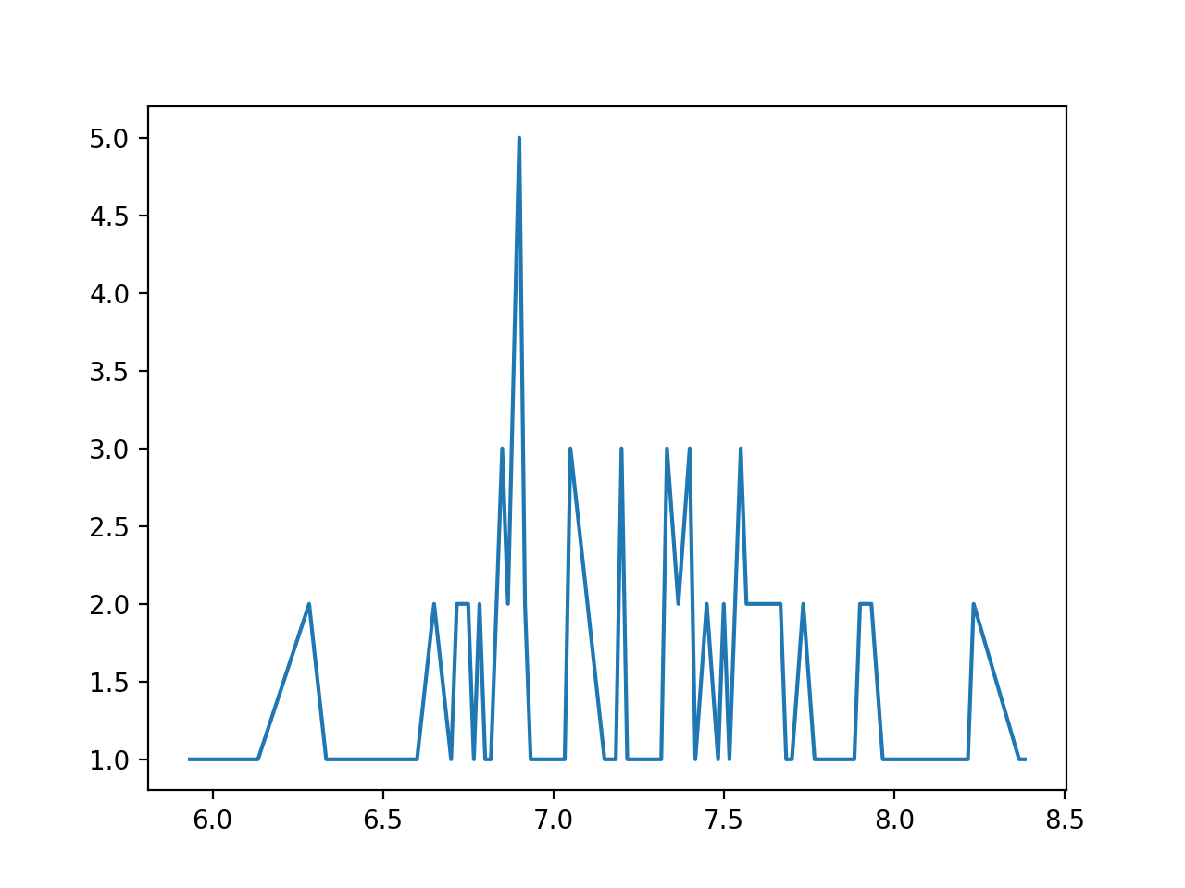

The x axis is the number of minutes it takes me to solve the cube, and the y axis represents how many times a certain times has appeared in the simulation. I thought this is a bit inaccurate, so I ran 10000 trials, which took about 1h30m…

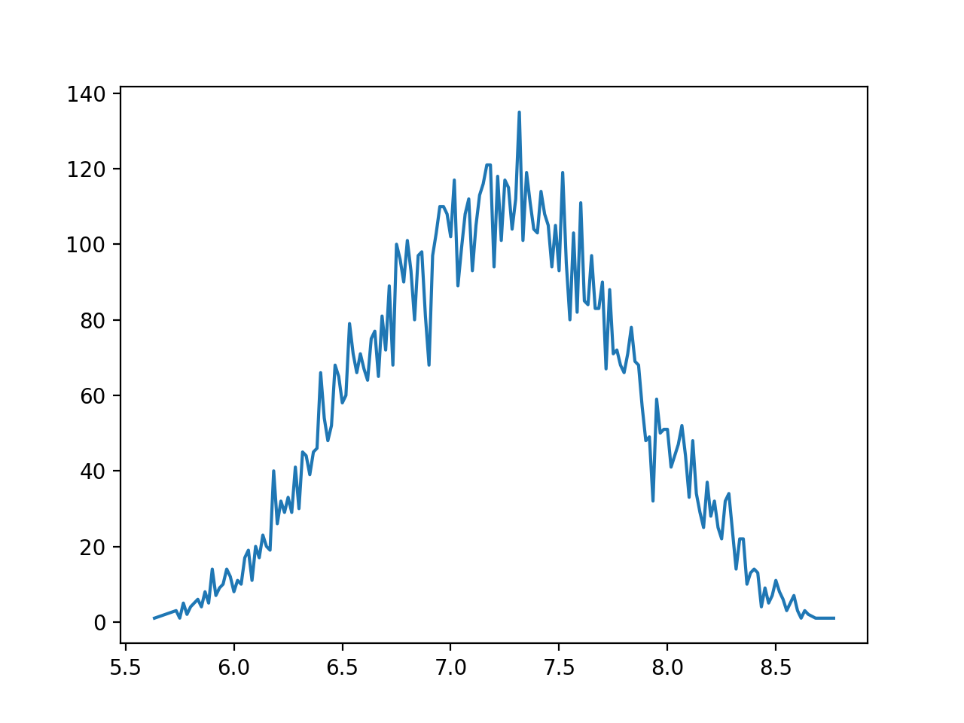

So the simulation shows that it would be most likely for me to get a 7.3 minute on 7x7.

And afterwards, I got my 7x7 and did my first solve on it. It is 16 minutes and 33 seconds… Nowhere close to where the simulation predicted. The most likely reason is that I am not yet familiar with 7x7. This simulation assumes that it takes the same amount of time to solve a piece on a 7x7 as on a 5x5, and that is really not true… The first time I solved it, there were a lot of pauses because I am not familiar enough with the puzzle and I couldn’t find pieces. Another important factor is that I could not turn a 7x7 as well as a 5x5. 7x7 is really big and it is really difficult to turn exactly how you want it to turn for the first time. It turns out the result of this simulation is fairly accurate given that now I do average around 7 minutes 30 seconds, but then the simulation would have been how much time it takes me to solve a 7x7 after a lot of practice. If I were to do a simulation of the first time I solve a 7x7, a lot of other estimations has to be made and this simulation totally doesn’t work. Still, I feel like the idea is good, but I just have to determine what simulation I really want to do.